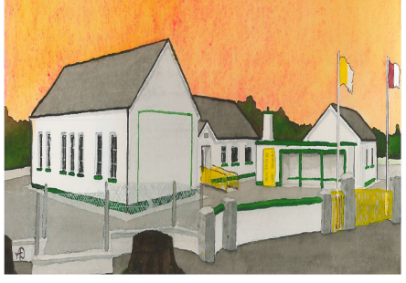
Kilglass NS BOM Agreed Report 21-01-25
- Finance - Bank reconciliation and budgets discussed and approved.
- New Buildings – we received correspondence from Dept of Education Buildings Unit that application for new classrooms had been declined. Parents, staff etc have been in contact with local TD’s and Councillors to re the above. School Management have sought advice from our Patron Body and Area Networks to seek advice on overturning this decision. As of today, our application has been brought back to the Buildings Unit and the NCSE has given their support to have our application reviewed.
- Sewage/ Waste water treatment – school management are to engage a consultant to prepare an application for Emergency Works.
- Enrolments – 5 children are on the waiting list for our ASD class, one child has gone elsewhere since our ASD class application had been declined.
- Erasmus – a group of 6th class students will visit Alavus, Finland as part of our Erasmus project. A risk assessment has been completed and budget agreed.
- Before and After-School – service has commenced and are awaiting approval from TUSLA School Age Childcare for affiliation.
- Parking – following meeting with Robert Troy (County Council) and Evelyn Parsons we have sought prices for extending our carpark, €30000 is the approximate costs. Given that there will be less traffic both in the morning and evening with Pre and Afterschool care, we will monitor to see if there is any improvements with traffic congestion, if there is no improvements we will have to fundraise to cover the cost of construction.
Signed:
Vincent Glynn
Secretary to the Board of Management

