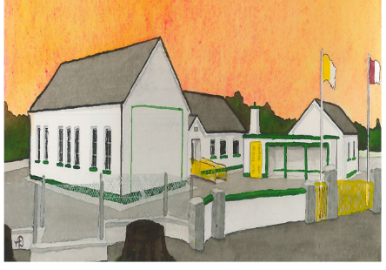
Kilglass NS BOM Agreed Report 14-05-24
- The Board of Management ratified the following policies:
  - Career Break/Job Share Policy
  - CCTV Policy
  - Staff Mobile Phone Policy
- The school calendar for the school year 2024/25has been approved by the Board of Management and is attached to this report.
- The school will close on June 7th for local/European elections
- Safety at Drop off and Pick Up times: The County Council have made recommendations for improvement of car park/school traffic, the BOM will cost these recommendations
- The Schools Photovoltaic Programme (Solar Panels) has been installed and our students can track our energy creation from installed monitor in the school.
- The Schools Annual 5km Walk/Run will take place on Sunday June 9th in collaboration with our Parents Association.
- The soft play area and fencing has been completed, the BOM have applied for 3 additional classrooms, SET room, Multi-Purpose/PE Hall, staffroom and Principal Office.
- The school will have 15 new Junior Infants in September 2024 giving a total enrolment of 140 students.
- Classes have been allocated as follows for 2024/25:
Junior Infants – Ms Tully
Senior Infants – Ms Bonner
First/Second Class – Ms Braithwaite
Third/Fourth Class – Mr Kane
Fifth/Sixth Class – Ms Mullins
Hazel Room – Ms Poland
SET – Ms Beattie & Mr Glynn
Signed:
Vincent Glynn
Secretary to the Board of Management

